Falafels
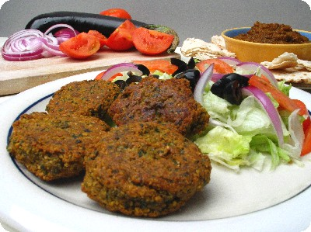
Serves: 4
Difficulty: medium
Prep & Cook time: 2 hours

Falafel Recipe:
250 ml dried garbanzo beans
125ml dried fava beans
125ml cilantro (coriander leaves)
50ml parsley
4 garlic cloves minced
5ml salt
7ml coriander
3ml cumin
1 med onion
1ml blk pepper
1 ml cayenne pepper (optional)
50 ml bread crumbs
25ml flour
5ml baking soda, added 15 minutes before frying
1 ml baking powder

1.Open and drain the beans. Pat dry to get rid of any excess moisture.
2. Blend the garbanzo beans and fava beans in a food processor until the beans are the consistency of bread crumbs, empty into a large bowl.
3. Next put the onion, garlic, cilantro and parsley in the blender and blend until it is a paste consistency, add to bean mixture.
4. To the bowl add the cumin, coriander, salt, black pepper, bread crumbs and cayenne pepper and mix very well. Taste to see if you would like to add more salt or not.
5. Stir in the baking soda, baking powder and flour to the bean mixture and mix well, let sit 15-20 minutes before frying.
6. Heat about 50ml vegetable oil into frying pan, turn to medium-low heat.
7. Mold the falafel mixture into small balls and drop into oil to fry, continually turn over the falafel balls to keep the color an even brown on all sides, when they are a medium brown color, remove the balls and drain on a paper towel for a minute. Serve warm and fresh with tahini sauce

