Fried Rice

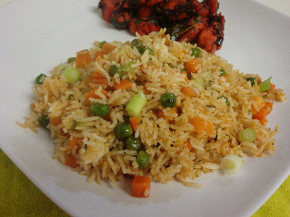
Ingredients

375-500 ml cooked rice
1 green onion
½ stalk celery
25 ml oil
50 ml peas
1 slice deli ham
1 egg
10-15 ml soy sauce

Method

- Prepare rice according to rice recipe.
- Chop onion and celery into thin diagonal slices.
- Heat oil in a wok over medium – high heat. Add onion and celery, and stir-fry until soft.
- Beat the egg slightly. Add egg, cooked rice, peas, ham and soy sauce to the vegetables in the wok. Stir-fry 1 to 2 minutes or until heated through.

