Healthy Cajun Style French Fries

- 1ml oregano
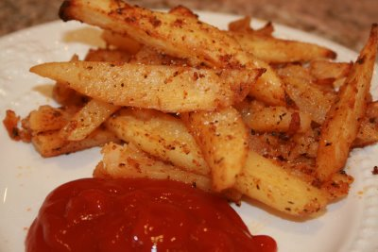
- 1ml thyme
- 3ml paprika
- 1ml cayenne
- 1ml black pepper
- 1ml sugar
- 1mlcumin
- 2ml salt
- 3ml garlic powder
- 2ml onion powder
- 2mlTabasco sauce
- 10ml vegetable oil
- two potatoes

*If you do not enjoy Cajun style French fries, you may substitute all the spices with 1 tablespoon (15ml of seasoning salt) and some pepper to taste.

Directions:

Preheat oven to 450 degrees F.
In a small bowl, combine oregano, thyme, paprika, cayenne, black pepper, sugar, cumin, salt, garlic powder, onion powder, Tabasco sauce, and oil; mix well into a paste.
Line a large baking sheet with aluminum foil; pour a small amount of oil onto foil and spread with a paper towel.
Peel potatoes and slice into french fry shapes.
Place fries in bowl and mix well
Place fries on lined baking sheet
Bake in preheated oven for approximately 20-25 minutes (your time may vary with the size fry you cut); turn once during cooking to brown underside.
Please explain how these French fries are healthier for you than ones purchased at a fast food chain?
________________________________________________________________________________________________________________________________________________________________________________________________________________________________________________________________________________________________________________________________________________

