Hummus
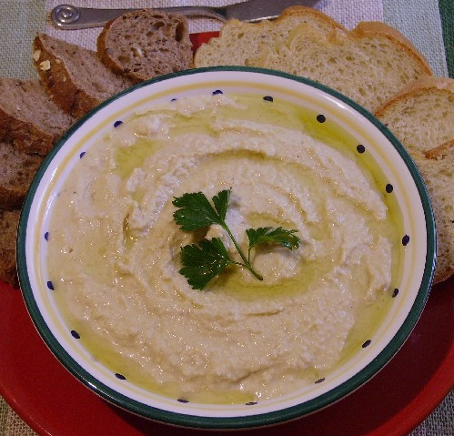

Ingredients

125 ml canned chick peas, drained
80 ml tahini
60 ml lemon juice
1 clove mashed garlic
2 ml salt
½ -1 ml cumin oil

Method
- Place thick peas, tahini, lemon juice, garlic, salt, and cumin in food processor. Mix until smooth.
- The humus may be a bit thick, so thin it out by adding a bit of oil or liquid from the can of chick peas.
- Refrigerate.

