PANAGO PIZZA DOUGH RECIPE
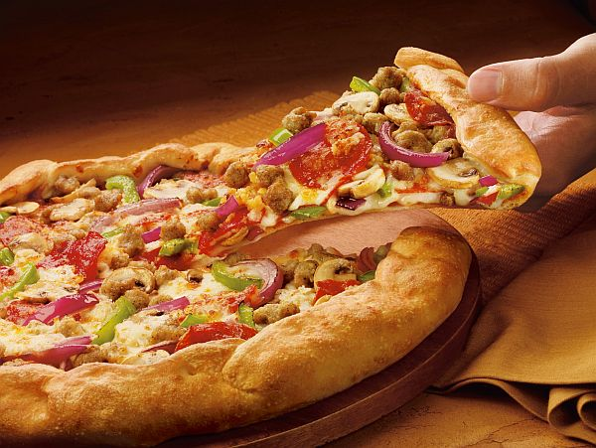
Ingredients:
- 15ml dry yeast
- 300ml warm water
- 750ml all-purpose flour
- 250ml whole wheat flour
- 5ml sea salt
- 30ml olive oil
- 15ml honey

Method:
  - In a medium bowl, combine the warm water (not too hot or you'll kill the yeast), honey and yeast until dissolved.
  - Leave for 5 - 10 minutes unti lthe yeast activates and the mixture develops a layer of froth on the surface.
  - In a large bowl, mix the sea salt and 2 types of flour and make a well in the center.
  - Add the yeast and olive oil.
  - Mix together , then use your hands until the dough comes together.(I did this step in my kitchenaid.).
  - Tip the dough onoto a lightly floured surface and knead until th edoor is smooth, shiny and elastic (about 5 - 10 minutes) or allow the kitchenaid to do this.
  - If the dough is too sticky or soft, add a little extra flour or if it's too dry and crumbly, add a little water.
  - Shape the dough into a round ball and place in a large, oiled bowl.
  - Cover with a damp cloth for roughly 45 minutes or until the dough doubles in size.
  - Punch down the dough to remove the air and place it on a lightly floured work surface.
  - Divide in 2 and shape each piece into round disks.
  - Place the dough balls on a sheet of parchment.
  - Cover with a light coating of oil and let them rise again, for about 20 minutes.
  - Dough is now ready to add whatever toppings you like and cook.
  - Bake in a 400 degree oven for approximately 10 minutes. Keeping an eye on it until the cheese browns and the crust looks done.

ENJOY!!!!

