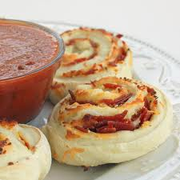
Pizza Rolls
Ingredients
Dough
300mL flour
10mL baking powder
1mL salt
65mL butter
125mL milk

Filling
50mL pizza sauce
- 2mL oregano, Italian seasoning, garlic powder, basil
1 chunk of mozzarella
1 piece green pepper
3mL pepperoni (optional)

Method
- Turn to 425˚F. Lightly grease muffin pan
- Sift and measure flour. Sift again with baking powder and salt.
- Cut in butter with pastry blender until mixture resembles fine crumbs.
- Add the milk and stir lightly with a fork.
- Place dough on lightly floured breadboard and knead gently 8 to 10 times. Roll out into an 8” x 12” rectangle.
- Spread pizza sauce over dough. Sprinkle on grated cheese and chopped green pepper.
- Rolls tightly like a jelly roll start at wide edge. Cut roll into 6 slices, using thread.
- Place rolls cute side up into muffin pans. Bake 12 – 15 minutes or until light brown

