Tzatziki Sauce
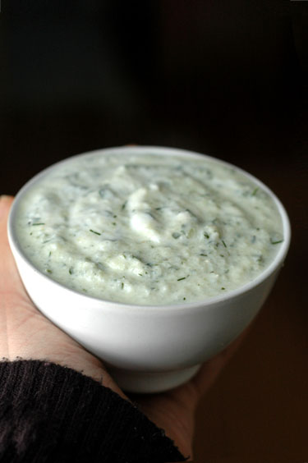

Ingredients

40 ml of thick Greek yogurt
1 clove of garlic, finely chopped
30 ml of grated cucumber
5 ml of olive oil
7 ml of lemon juice

Method

- Combine oil and lemon juice in a medium mixing bowl.
- Fold the yogurt in slowly, making sure it mixes completely with the oil.
- Add garlic and the grated cucumber.
- Mix together and place in the refrigerator until ready to serve

