Whole wheat pita bread
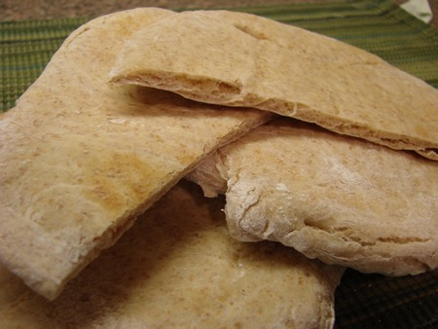
Ingredients

2.5 ml sugar
12.5 ml warm water
7.5 ml yeast
275 ml all purpose flour
60 ml whole wheat flour
2.5 ml salt
12 ml olive oil

Method- Day 1

- In a large bowl mix whole wheat flour, sugar, salt, and undissolved yeast.
- Slowly add oil and warm water to dry ingredients and beat vigorously with a wooden spoon until smooth.
- Gradually stir in all-purpose flour until a soft dough has formed
- Place on a lightly floured surface and knead for 10 minutes.
- Place into a greased bowl (using oil), and grease the top of dough with oil.
- Cover loosely with saran wrap and seal the edges.
- Make sure names are on the bowl and refrigerate

Method- Day 2

- Preheat oven to 260 degrees Celsius
- Punch down dough on a lightly floured surface.
- Divide into 4 equal pieces.
- Knead each ball, then roll it out with a rolling pin to make a circular shape.
- Bake for 2-5 minutes on a baking sheet until browned. Cut pita bread across the middle to make a pocket.

